

# Crude Oil Price Prediction

**A PROJECT REPORT**

***Submitted by***

|  |  |
| --- | --- |
| **THANGAPANDI.A** | **(721819205028)** |
| **NANDHAKUMAR.S** | **(721819205014)** |
| **ANAND.R** | **(721819205005)** |
| **RAHUL.S** | **(721819205017)** |

***in the partial fulfilment of the requirements for the award of a degree of***

**BACHELOR OF TECHNOLOGY**

**IN**

**INFORMATION TECHNOLOGY**

**RATHINAM TECHNICAL CAMPUS, COIMBATORE.**

**ANNA UNIVERSITY : CHENNAI 600 025**

### NOVEMBER & 2022

**Project Report Format**

1. **INTRODUCTION**
   1. Project Overview
   2. Purpose
2. **LITERATURE SURVEY**
   1. Existing problem
   2. References
   3. Problem Statement Definition
3. **IDEATION & PROPOSED SOLUTION**
   1. Empathy Map Canvas
   2. Ideation & Brainstorming
   3. Proposed Solution
   4. Problem Solution fit
4. **REQUIREMENT ANALYSIS**
   1. Functional requirement
   2. Non-Functional requirements
5. **PROJECT DESIGN**
   1. Data Flow Diagrams
   2. Solution & Technical Architecture
   3. User Stories
6. **PROJECT PLANNING & SCHEDULING**
   1. Sprint Planning & Estimation
   2. Sprint Delivery Schedule
   3. Reports from JIRA
7. **CODING & SOLUTIONING (Explain the features added in the project along with code)**
   1. Feature 1
   2. Feature 2
   3. Database Schema (if Applicable)
8. **TESTING**
   1. Test Cases
   2. User Acceptance Testing
9. **RESULTS**
   1. Performance Metrics
10. **ADVANTAGES & DISADVANTAGES**
11. **CONCLUSION**
12. **FUTURE SCOPE**
13. **APPENDIX**

Source Code

GitHub & Project Demo Link

INTRODUCTION

* 1. **Project Overview**

Crude oil is one of the most important energy resources on earth. So far, it remains the world's leading fuel, with nearly one-third of global energy consumption.

Crude oil prices are determined by many factors and have a big impact on the global environment and economy. Although crude oil prices were firm in early 2014, they fell sharply from mid- 2014.

In January 2016, the [U.S.](https://www.sciencedirect.com/topics/earth-and-planetary-sciences/united-states-of-america) refiner acquisition cost for crude oil imports, as a proxy for world oil price, is only $28.81 per barrel on average, and the West Texas Intermediate (WTI) crude oil spot price, as the benchmark oil price in North America, is only $31.68 per barrel on average. The prices have dropped by more than seventy percent since June 2014.

The world's environment is affected by the oil price falling. With the drop of oil prices, the fuel bills are lowered. As a result, consumers are very likely to use more oil and thus increase the [carbon emission](https://www.sciencedirect.com/topics/earth-and-planetary-sciences/carbon-dioxide-emission). In addition, there is less incentive to develop renewable and clean energy resources.

On the other hand, sustained low oil prices could lead to a drop in global oil and [gas exploration](https://www.sciencedirect.com/topics/earth-and-planetary-sciences/natural-gas-exploration) and exploitation activities.

Fluctuating oil prices also play an important role in the global economy.

The fall in oil prices would result in a modest boost to global economic activity, although the owners of oil sectors suffer income losses. Recent research from the World Bank shows that for every 30% decline of oil prices, the global GDP (Gross Domestic Product) would be increased by 0.5%. At the same time, the drop of oil prices would reduce the cost of living, and hence the inflation rate would fall.

There is no doubt that crude oil price forecasts are very useful to industries, governments as well as individuals. Thus, forecasting crude oil prices has been the subject of research by both academia and industry. Many methods and approaches have been developed for predicting oil prices. However, due to the high volatility of oil prices, it remains one of the most challenging forecasting problems.

whenever new oil price data are available, with very small constant overhead. We compare our stream learning model with three other popular oil price prediction models for predicting two types of oil prices (the U.S. refiner acquisition cost for crude oil imports and the WTI crude oil spot price). The experiment results show that our stream learning model achieves the highest accuracy in terms of both

## Purpose

According to economic theory, the price of crude oil should be easily predictable from the equilibrium between demand and supply, wherein demand forecasts are usually made from GDP, exchange rates and domestic prices, and supply is predicted from past production data and reserve data.

We have chosen Linear Regression which is the best fit among Random Forest, Support Vector Regression (rbf) model, polynomial model, and linear model), and Linear Regression.

The predictions are most approximate with Linear Regression Algorithm. The algorithm automatically uses the kernel function that is most appropriate to the data



2. **LITERATURE SURVEY**



2.1 Existing problem

We did a survey over the possible sources that we could access. In our exploration, we did find the authors.

Authors:Ms.Bhanupriya.N our mentor proposed the literature on forecasting the black gold price is vast. This paper provides a literature review on the various techniques that have been used to forecast crude oil price. They mainly focused on the researches that have utilized artificial neural network models in their forecasting study. Therefore, a detailed description of this model was presented in the paper[1].

The goal of this article is to review the existing literature on crude oil price forecasting. They categorized the existing forecasting techniques into the two main groups of quantitative and qualitative methods; and then performed an almost comprehensive survey on the available literature with respect to these two main forecasting techniques. A review on the existing literature about crude oil price forecasting. For this purpose they distinguished forecasting methods into the two main techniques of quantitative and qualitative techniques [2].

In this paper [3], they develop a new research framework for core influence factors selection and forecasting. Firstly, this paper assesses and selects core influence factors with the elastic-net regularized generalized linear Model (GLMNET), spike-slab lasso method, and Bayesian model average (BMA). Secondly, the new machine learning method long short-term Memory Network (LSTM) is developed for crude oil price forecasting. Then six different forecasting techniques, random walk (RW), autoregressive integrated moving average models (ARMA), elman neural Networks (ENN), ELM Neural Networks (EL), walvet neural networks (WNN) and generalized regression neural network Models (GRNN) were used to forecast the price. Finally, we compare and analyze the different results with root mean squared error (RMSE), mean absolute percentage error (MAPE), directional symmetry (DS). This empirical results

show that the variable selection-LSTM method outperforms the benchmark methods in both level and directional forecasting accuracy [3].

The following price forecasting techniques have been covered: (i) artificial neural network, (ii) support vector machine, (iii) wavelet, (iv) genetic algorithm, and (v) hybrid systems. In order to investigate the state of artificial intelligent models for oil price forecasting, thirty five research papers (published during 2001 to 2013) had been reviewed in form of table (for ease of comparison) based on the following parameters:

Al methods used in complex oil price related studies. The review further extended above overview into discussions regarding specific shortcomings that are associated with feature selection for designing input vector, and then concluded with future insight on improving the current state-of-the-art technology[4].

Oil embodies a vital role in the world economy as the backbone and origin of numerous industries. It is an important source of energy representing an indispensable raw material and as a major component in many manufacturing processes and transportation. Oil price suffer from high volatility and fluctuations. In global markets, it is the most active and heavily traded commodity. Recently many studies emerged to discuss the problem of predicting oil prices and seeking to access to the best outcomes. Despite these attempts there were no enough studies that could be used as a reference covering all aspects of the problem. In this research, a comprehensive survey covering the previous methods and some results and experiments are presented with a focus on and maintaining the necessary steps when predicting oil prices[5].

## LITERATURE REVIEW:

Author’s:

B. Shehata, G. G. Mohamed, M. A. Gab-Allah

The creation of a natural-matrix reference material for measuring the amounts of sulphur, iron, nickel, vanadium, and magnesium in crude oil is discussed in this work. In order tocreate the candidate material, the crude oil was homogenised and packaged. The generated reference material's homogeneity and stability were examined, and gravimetric and wavelength- dispersive X-ray fluorescence (WDXRF) spectroscopy were used to characterise the sulphur content. Atomic absorption spectrometry (AAS) and inductively coupled plasma-optical emission spectrometry (ICP-OES) techniques were used to characterise the contents of iron, nickel, vanadium, and magnesium. Atomic absorption spectrometry (AAS) and inductively coupled plasma-optical emission spectrometry (ICP-OES) techniques were used to characterise the contents of iron, nickel, vanadium, and magnesium. The candidate reference material has good homogeneity and stability, according to statistical analysis of the data. The degree of agreement between characterization methods was sufficiently high to permit certification. Using a technique established by the National Institute for Standards and Technology, which involves merging data from two or more independent analytical methods, the certified values and their related uncertainties were statistically determined. crude oil has been developed by multiple analytical methods. Statistical analysis of the data showed that the reference material is sufficiently homogenous and stable. This reference material will be a useful tool for validation of the analytical methods, for quality control in crude oil analysis and for establishing traceability of the measurement results to the SI unit.

Linear and Non-Linear Modelling of Nigerian CrudeOil Prices

Author’s :

Wiri Leneenadogo ,Sibeate Pius U

The time plot's revelation of the series' upward and downward movement leads one to speculate that it displays a pattern of regime switching known as the cycle of expansion and contraction. The Augmented Dickey-Fuller test was employed to check for stationarity at lag one.Seven models were estimated for the linear model (univariate linear ARIMA (p, d, q)) and two models were estimated for the non-linear model (univariate non-linear MS-AR). AIC (2.006612),SC

(2.156581), and the highest log-likelihood of (-150.5480) for the crude oil were used. Hamilton

3) shows that the drops in real GDP in the US inresponse to various disruptions to crude oil

uction over the course of the second halfof the twentieth century were greater than the factorshare argument would predict. Thus,our results also have important implications for central tenants of macroeconomics suchas business cycle theories. Hendry and Juselius (2000) suggestedthat “the impact ofstructural change in the world oil market is [a potential source] of

stationarity”.oil production contain a unit root, through the transmission mechanis m to realincome

deviations from long-run growth would lose their empiric noted, if real output contains a unit

, this “challenges a broad spectrum ofmacroeconomic theories designed to produce and

understand transitory fluctuations”

Source of data - Time plot.

Linear models - Autoregressive (AR) models of order (p) , Stationarity conditions for AR (P) process .

Moving Average (MA) model. Invertibility condition for (MA) model.

Autoregressive-Moving-Average Models (ARMA). ARIMA model with differencing.

Non-linear modelling - Markov switching model, Markov switchingautoregressive model (MS-AR) .

Forecasting Model for Crude Oil Price Using ArtificialNeural Networks

Author’s:

Siddhivinayak Kulkarni , Imad Haidar

Author’s :

Wiri Leneenadogo ,Sibeate Pius U

In the advanced global economy, crude oil is a commodity that plays a major role in everyeconomy. As Crude oil is highly traded commodity it is essential for the investors, analysts, economists to forecast the future spot price of the crude oil appropriately. In the last year the crudeoil faced a historic fall during the pandemic and reached all time low, but will this situation last? There was analysis such as fundamental analysis, technical analysis and time series analyses whichwere carried out for predicting the movement of the oil prices but the accuracy in such predictionis still a question. Thus, it is necessary to identify better methods to forecast the crude oil prices. This study is an empirical study to forecast crude oil prices using the neural networks A model must take a subset of the information provided, attempt to map it to the desired target, and then generate a forecast albeit with a given level of accuracy, or error ANN is chosen as a mapping model in this context and is seen as a nonparametric, nonlinear, assumption-free model . The neuralnetwork proved to be efficient in forecasting in the modern era. A simple neural network performsbetter than the time series models. As a result, it does not make assumptions about the issue beforeconsidering the facts. The network structure was selected after systematic rigors tests involved large number of experiments on the crude oil data. In addition, two groups of inputs were tested ,crude oil futures data, and market data which include S&P500, gold price, Dollar index and heatingoil price. The results show that using futures data mainly contracts 1, 2 months to maturity has outperformed all other inputs tested for one step forecast. Moreover, strong evidence was found insupport of heating oil spot price to forecast crude oil spot price for multiple steps prediction

**Author’s:**

Quality and chemistry of crude oil

Ghulam Yasin, Muhammad Iqbal Bhanger, Tariq Mahmood Ansari, Syed Muhammad Sibtain Raza Naqvi, MuhammadAshraf, Khizar, Farah Naz Talpur

Crude oil composition (saturates, aromatics, and polar) of samples taken from several North American oil fieldsPakistan's Punjab and Sindh regions have been assessed using the ASTM(Americantechniques used by the Society for Testing and Material. Results from Punjab's North Region and the South RegionCrude oils from (Sindh) have been contrasted with one another. A crude oil is a naturally occurring mixture, consisting predominantly of hydrocarbons, sulphur, nitrogen and metals. Quality (Bawazeer et al., 1997) of the petroleum products is playing the majorrole of consumer satisfaction and speaks about the performance of the refineries. Crude oils are complex but mainly paraffinic, napthenic and aromatic (Wang et al., 1994). Crude oils contain allnormal alkenes from (Khanorkar et al., 1996) C1 to C120. However, this percentage rises to 35%in highly paraffmic and decreases to zero in highly biograded oils (Ali et al., 1989). Methane is

predominant component of natural gas and alkanes ranging from pentane to pentadecane are the chief constituents of straight run (uncrackcd) gasoline or petrol. Above C17, the alkanes are solidwax like substances and crude oils, which contain high concentrations of paraffin wax, will be viscous and have high cloud and pour points. These Paraffins consists of isoalkanes and methyl cycloalkanes Sindh crude is superior to Punjab crude.oils because they have a low pour point, lowviscosity, low specific gravity, and low sulphur content. Allbased on total, the examined samples are of the sweet variety. North region crude oils are of sweet type while some samples of South region belong to sour type crude oils. North region crude oils belong to light crude oil class whileone sample of South region belongs to medium class crude oils. North region (Punjab) crude oils have more saturates aromatics and polar contents than that of South region (Sindh) crude oils.

UNDERSTANDING CRUDE OIL PRICES

**Author’s:**

James D. Hamilton NBER.

This article describes some of the key features of the oil market and then discusses the pricing of oil, highlighting the important role of the futures market. It also notes some related issues for the oil market. Topics discussed include the role of commodity speculation, OPEC, andresource depletion. This is true in terms of both production and financial market activity. In termsof statistical regularities, the paper notes that changes in the real price of oil have historically tended to be permanent, difficult to predict, and governed by very different regimes at different points in time. From the perspective of economic theory, we review three separate restrictions onthe time path of crude oil prices that should all hold in equilibrium. The first of these arises from storage arbitrage, the second from financial futures contracts, and the third from the fact that oil is a depletable resource. We also discuss the role of commodity futures speculation. In terms of the determinants of demand, we note that the price elasticity of demand is challenging to measurebut appears to be quite low and to have decreased in the most recent data. Income elasticity is easier to estimate, and is near unity for countries in an early stage of development but substantiallyless than one in recent U.S. data. We also relate the challenge of depletion to the past and possiblefuture geographic distribution of production. Our overall conclusion is that the low price- elasticityof short-run demand and supply, the vulnerability of supplies to disruptions, and the peak in U.S.oil production account for the broad behavior of oil prices over 1970-1997. Although thetraditional economic theory of exhaustible resources does not fit in an obvious way into this historical account, the profound change in demand coming from the newly industrialized countriesand recognition of the finiteness of this resource offers a plausible explanation for more recent developments. In other words, the scarcity rent may have been negligible for previous generationsbut may now be becoming relevant Yet its pricing is relatively complex. Unquestionably the threekey features in any account are the low price elasticity of demand, the strong growth in demand from China, the Middle East, and other newly indus-trialized economies, and the failure of global

production to increase. These facts explain the initial strong pressure on prices that may have triggered commodity speculation in the price of petroleum.

Crude Oil Price Prediction using Artificial Neural Network

Author’s:

Nalini Gupta, Shobhit Nigam

Predicting oil prices is now essential; it benefits many big and small businesses, people, and the government. The evaporative nature of crude oil, its price prediction becomes extremely difficult and it is hard to be precise with the same. Several different factors that affect crude oil prices. We propose a contemporary and innovative method of predicting crude oil prices using theartificial neural network (ANN). The main advantage of this approach of ANN is that it continuously captures the unstable pattern. This work indicates that the ANN model is an effectivetool for crude oil price prediction and can be efficiently used for short term price forecasting by determining the optimal lags. The proposed model is powerful and highly suggested because investors can use it not only to initiate trades but also as an effective tool to judge various strategiesrelating.

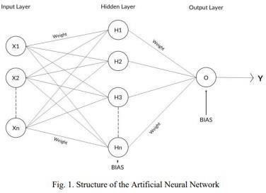

Computing systems based on artificial neural networks, also known as connectionist systems, are theoretically similar to, but not exactly the same as, biological neural networks found in the human

body. An ANN performs its task by taking in examples and requires no programming with task-specific rules . A neural network's job is to create or develop an output pattern

from an input pattern. An artificial neural network (ANN) has an architecture whichis parallelly- distributed with large number of nodes (neurons) and connections.

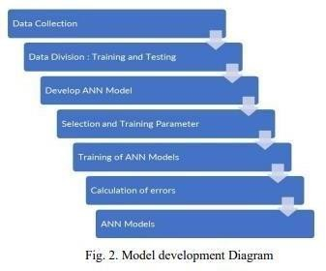

We use the Back-propagation learning algorithm and the error signal is cultivated through the network in the backward direction by changing and managing weights of the network to maximize the performance of the network. The procedure is done until the network is able to provide desired responses.

In the suggested model, there is only one dependent variable, the closing price of crude oil which has been considered, since it’s a time series, we have followed the model for general time series forecasting in conducting the experiments, which have been represented in the form as follows:





## Reference

Manel Hamdi & Chaker Aloui, 2015. "Forecasting Crude Oil Price Using Artificial Neural Networks: A Literature Survey," Economics Bulletin, AccessEcon, vol.35(2), pages 1339-1359.

Bashiri Behmiri, Niaz and Pires Manso, José Ramos, Crude Oil Price Forecasting Techniques: A Comprehensive Review of Literature (June 6, 2013).

Quanying Lu, Shaolong Sun, Hongbo Duan & Shouyang Wang, Analysis and forecasting of crude oil price based on the variable selection-LSTM integrated model: Proceedings of the Energy Informatics.Academy Conference Asia 2021

Sehgal, N.; Pandey, K.K. Artificial intelligence methods for oil price forecasting: A review and evaluation. Energy Syst.2015,6,479–506.

Dietterich, T. G.,''Ensemble methods in machine learning''. In Multiple classifier systems pp. 1-15, Springer Berlin Heidelberg, 2000

Problem statement

# Problem statement

## Supply

Supply and demand has to do with how much oil is available.

Supply has historically been determined by countries that are part of [OPEC](https://www.cnbc.com/id/10000937). But now, the United States is playing a bigger role in supply thanks to booming production from American shale fields. So if major oil-producing countries are pumping out a lot of crude, the supply will be high.

Just look at what happened in 2014.

“Saudi Arabia made the decision that they were not going to cut back production, they were going to continue to produce at record high levels,” said Tamar Essner, senior energy director at Nasdaq IR Solutions.

“At the same time, you had very robust output from the United States, and from other producers around the world.”

Oil prices fell sharply as producers pumped more than the world could consume. OPEC was largely blamed for the free fall in oil prices because it refused to cut down its production. But OPEC said U.S. shale drillers were to blame for pumping too much, and should cut their production first.

In 1973, Arab members of OPEC put an embargo against the United States as a retaliatory measure for

U.S. support of Israel during the Yom Kippur War. After the embargo, the oil supply in the U.S. was so scarce and the demand was so high, it drove the price of crude to the point that gas stations began rationing gasoline.

## Demand

Demand on the other hand is determined by how much need there is for oil at a given time. That need is often for things like heat, electricity and transportation. The more economic growtha region sees, the more demand there will be for oil.

“Economies around the world have picked up since the financial crisis, and growth has gotten stronger so people have been using more energy,” Essner said.

And then there’s the question of how the market will react to renewable energy.

“A lot of this will be impacted by public policy, but at the end of the day renewable can only displace hydrocarbons if it’s economically feasible,” Essner said.

“Right now, renewables are still more expensive than hydrocarbons, so consumers aren’t goingto voluntarily make the switch.”

## Geopolitics

Since supply is determined by the big oil-producing countries, tension with one of those nationscan cause major problems. So if there’s war or conflict in an oil-producing region, crude inventories could seem threatened, and that could ultimately alter the price of oil.

“Geopolitics has traditionally been a factor in the oil price,” Essner said.

“Particularly when situations in the Middle East or other oil-rich regions of the world would flareup and there would be conflict, you would generally speaking see a little bit of an uptick in the price of oil as a result, just by virtue of the risk of supply being disrupted, or of means of transportation being disrupted, such as a canal or pipeline or workers going on protest, things like that.”

Just think back to the Gulf War of 1991. Oil production fell, which caused prices to rise.

And in 2003, oil prices soared after the U.S. invaded Iraq. That Middle Eastern nation producesa lot of oil, and with instability in the region, people weren’t immediately sure what would happen to the supply.

“That’s what makes the oil markets so fascinating, is that it’s really a very interesting interplay of financial markets, the economy, and those are two very different things, the currency market,geopolitics and the environment,” Essner said.

The energy industry is sure to evolve, and experts are watching to see what role oil will play in the future. But for now, the oil markets remain a powerful force in the world of economics, geopolitics and your budget.

## Geopolitics

Since supply is determined by the big oil-producing countries, tension with one of those nationscan cause major problems. So if there’s war or conflict in an oil-producing region, crude inventories could seem threatened, and that could ultimately alter the price of oil.

“Geopolitics has traditionally been a factor in the oil price,” Essner said.

“Particularly when situations in the Middle East or other oil-rich regions of the world would flareup and there would be conflict, you would generally speaking see a little bit of an uptick in the price of oil as a result, just by virtue of the risk of supply being disrupted, or of means of transportation being disrupted, such as a canal or pipeline or workers going on protest, things like that.”

Just think back to the Gulf War of 1991. Oil production fell, which caused prices to rise.

And in 2003, oil prices soared after the U.S. invaded Iraq. That Middle Eastern nation producesa lot of oil, and with instability in the region, people weren’t immediately sure what would happen to the supply.

“That’s what makes the oil markets so fascinating, is that it’s really a very interesting interplay of financial markets, the economy, and those are two very different things, the currency market,geopolitics and the environment,” Essner said.

The energy industry is sure to evolve, and experts are watching to see what role oil will play in the future. But for now, the oil markets remain a powerful force in the world of economics, geopolitics and your budget.

## IDEATION & PRPOSED SOLUTION:

* 1. **Empathy map canvas:**



* 1. Ideation & Brainstorming:

Brainstorming provides a free and open environment that encourages everyone within a team to participate in the creative thinking process that leads to problem solving.

Prioritizing volume

over value, out-of-the-box ideas are welcome and built upon, and all participants ar encouraged to collaborate, helping each other develop a rich number of creative solutions.

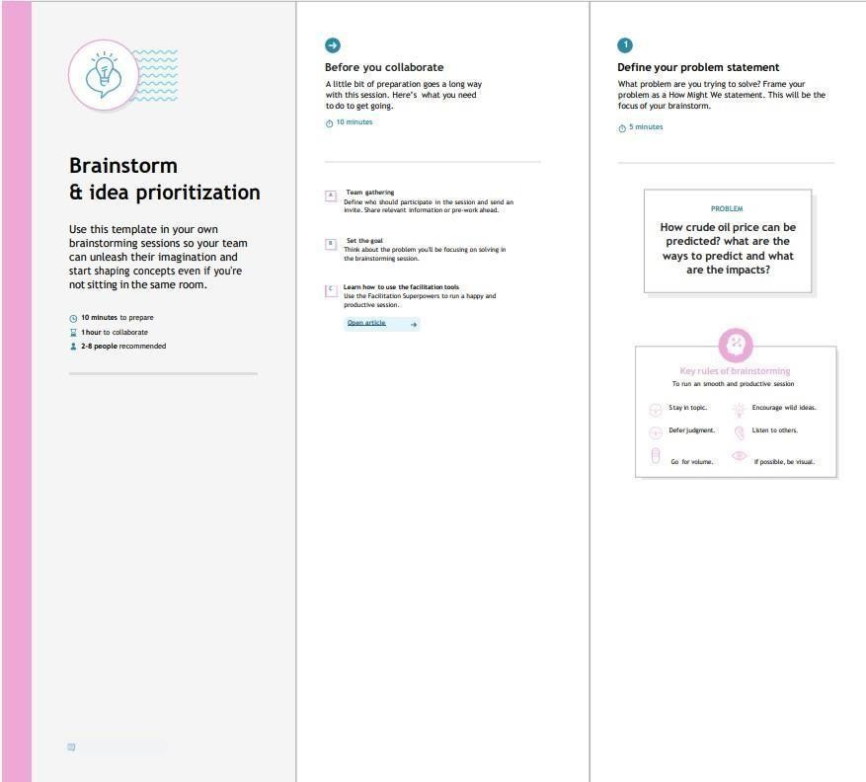

Step-1: Team Gathering, Collaboration and Select the Problem Statement

## 3.2 Brainstorming:

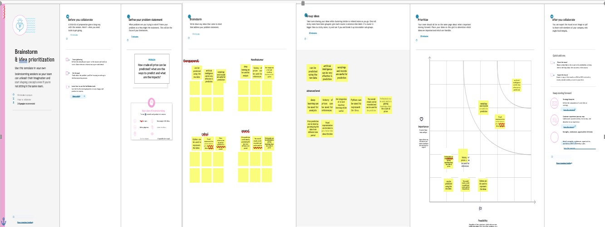

Step-3: Idea Prioritization

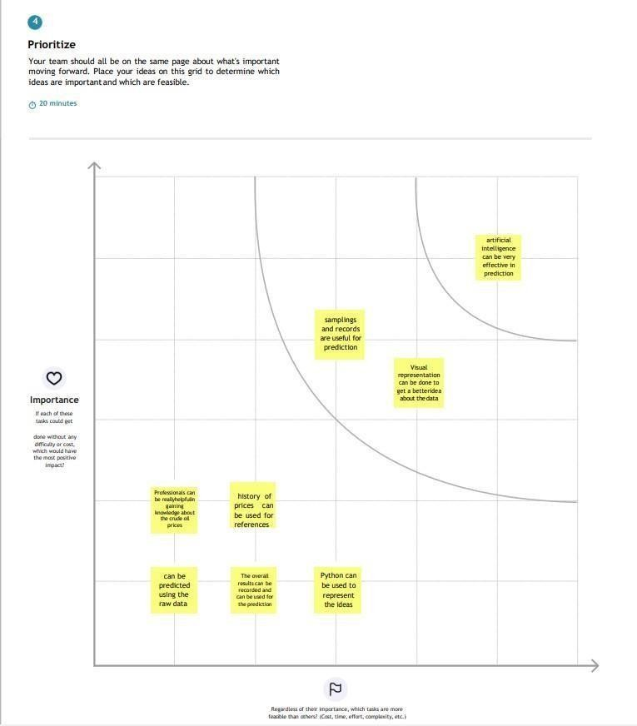

|  |  |  |  |  |
| --- | --- | --- | --- | --- |
| **3.3 Proposed Solution:** | | | | |
|  | **S.No.** | **Parameter** | **Description** |  |
| 1. | Problem Statement (Problem to be solved) | Crude oil is the world’s leading fuel, and its prices have a big impact on the global environment and its forecasts are very useful to governments,industry  is  individuals.The continuous usage of statistical and econometric techniques including AI for crude oil price prediction might demonstrate demotions to the  predictionperformance. |
| 2. | Idea / Solution description | RNN is used with long short term memory to achieve future crude oil using previous history of crude oil.The cost is measured as the mean squared error to determine it's effectiveness.The performance of the proposed model is evaluated using the price data in the WTO crude oil materials |
| 3. | Novelty / Uniqueness | * Crude oil price fluctuations have a far reaching impact on global economies and thus price forecasting can assist in minimising the risks associated with volatilityin oil prices. * Price forecasts are very important to various stakeholders: governments, public and private enterprises, policymakers, and investors. |
| 4. | Social Impact / Customer Satisfaction | * It is used to predict the future price and use the oil according to the prices. * this price has direct effects on several goods and products and its fluctuations affect the stock markets. * Oil prices are not only driven by economic variables, but they are also affected by key events .. |
| 5. | Business Model (Revenue Model) | * It can help decision makers – either firms, private investors, or individuals – when choosing to buy or sell the crude oil * crude oil is one of the most profitable trading commodities for traders. * **RNN and LSTM models are used as the** * **benchmark model to predict the crude oilprices.** |
| 6. | Scalability of the Solution | * PCA, MDS and LLE methods are used toreduce the dimensions of the data |
|  |  |  |  |  |

|  |  |  |
| --- | --- | --- |
|  |  | * Improve the accuracy of the RNN and LSTM * models. |

## 3.4 Problem solution fit:

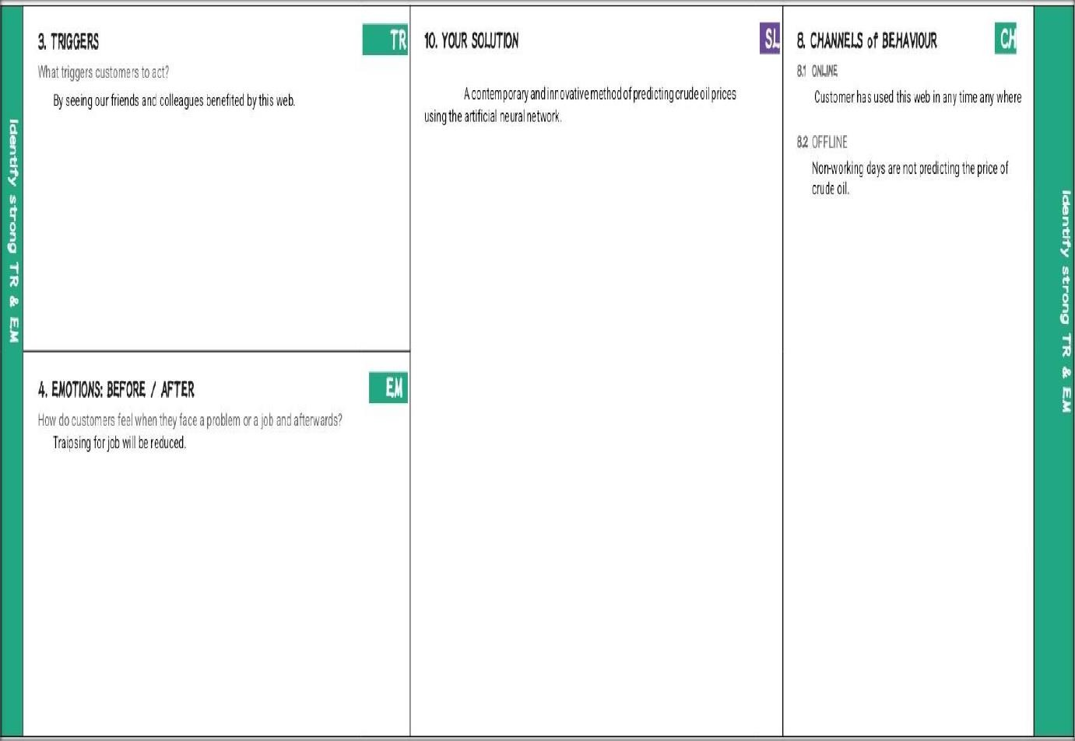

1. **REQUIREMENT ANALYSIS:**

## Function requirement:

Following are the functional requirements of the proposed solution.

|  |  |  |
| --- | --- | --- |
| **FR**  **No.** | **Functional Requirement (Epic)** | **Sub Requirement (Story / Sub-Task)** |
| FR-1 | User Application | User Direct Open With Google Play Store AppUser Can Download The Crude Oil Price |
| FR-2 | User Products Available | User Using The Application There Are So Many ProductsIn Crude Oil Price App  User Update The Energy And Oil Price Instant The Application |
| FR-3 | User Additional Features | User Can Read Latest News And View Oil Price ChartsUser View Major Energy Quotes  User Can Using A Multiple Color Themes |
| FR-4 | User Exceptions | User Can Exchange Rates And Currancy Converter |
|  |  |  |
|  |  |  |

## Non-functional Requirements:

|  |  |  |
| --- | --- | --- |
| **FR No.** | **Non-Functional Requirement** | **Description** |
| NFR-1 | **Usability** | Used to improve to the Accuracy of crude oil priceprediction |
| NFR-2 | **Security** | In the rising oil price can even shift economical/political power from oil importers to oil  exporters communications will be secured |
| NFR-3 | **Reliability** | Reliability of the pointing towards high –risk components |
| NFR-4 | **Performance** | Performance of the this project is to improve to theaccuracy of crude oil price prediction |
| NFR-5 | **Availability** | The Availability Solution is More Benefit for and  theImporters and exporters in the crude oil price prediction. |
| NFR-6 | **Scalability** | The scalability are 90%-95% |

Following are the non-functional requirements of the proposed solution.

## Project Design

* 1. **data flow diagrams:**

Data Flow Diagrams:

classic visual representation of how information moves through a system is a data flow diagram (DFD). A tidy and understandable DFDcangraphically represent the appropriate quantity of the system demand. It demonstrates how information enters and exits the system, what modifies the data, and where information is kept.

Example: [(Simplified)](https://developer.ibm.com/patterns/visualize-unstructured-text/)

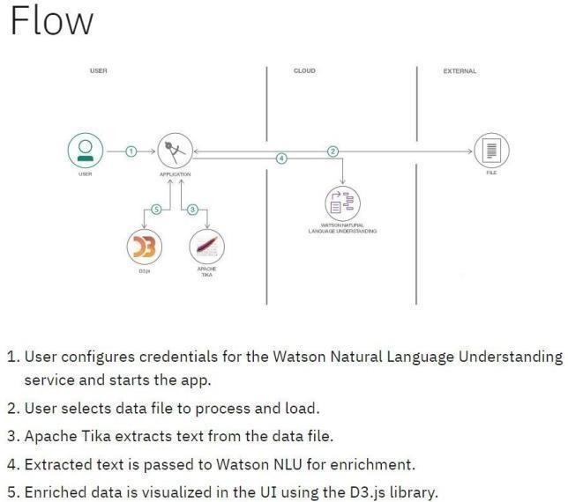

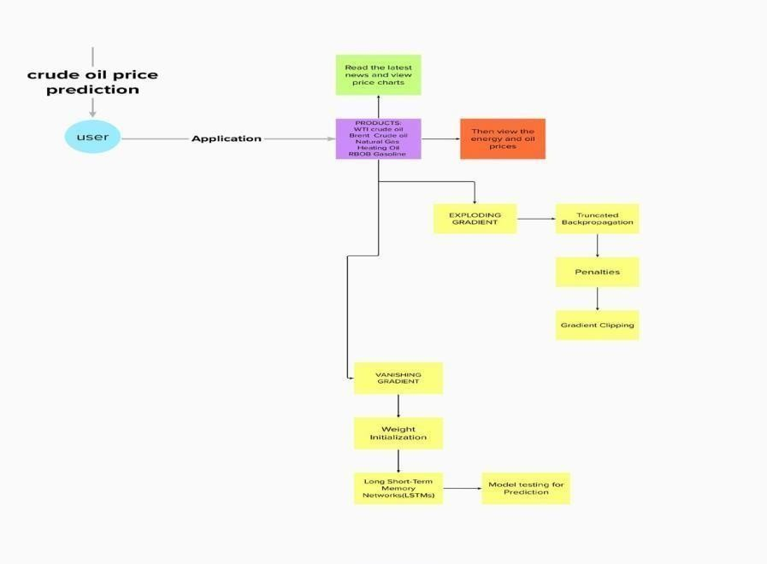

## Solution &Technical Architecture:

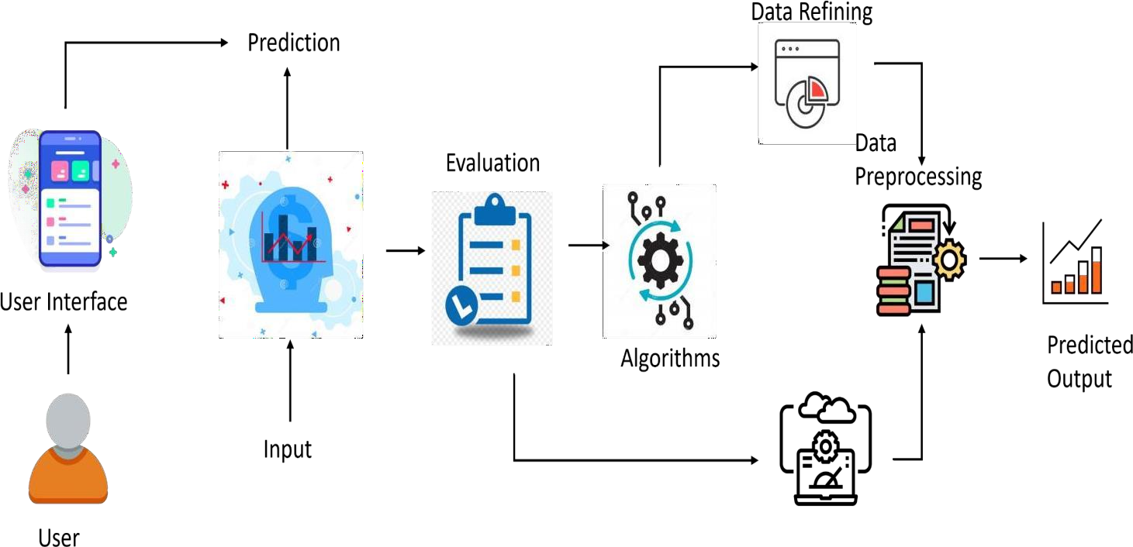

* 1. **User Stories:**

Use the below template to list all the user stories for the product.

|  |  |  |  |  |  |  |
| --- | --- | --- | --- | --- | --- | --- |
| **User Type** | **Functional Requirement**  **(Epic)** | **User Story Number** | **User Story/ Task** | **Acceptance criteria** | **Priority** | **Rel eas e** |
| Customer (Mobile User) | Registration | USN-1 | As a user,I can register for the application by  entering my email, password,and confirming my password. | I can access my account/ Displays Line gragh / Bar gragh. | High | Spri nt-1 |
|  |  | USN-2 | As a user,I will receive confirmation email once I have registered for the application | I can receive confirmation email & click confirm | High | Spri nt-1 |
|  |  | USN-3 | As a user,I can register for the application through Facebook | I can register & accessthe my Account | Low | Spri nt-2 |
|  |  | USN-4 | As a user,I can register for the application through Gmail | I can register through already logged in gmail account. | Medium | Spri nt-1 |
|  | Login | USN-5 | As a user,I can log into the application by entering email & password | After registration,I can log in by only email & password. | High | Spri nt-1 |
|  | Line\Bar gragh |  | After entering the inputs,the model will display predictions in Line\Bar Gragh Format. | I can get the expected prediction in various formats. | High | Spr int- 3 |
| Customer (Web user) | Login | USN-1 | As the web user,I can login simply by using Gmail or Facebook account. | Already created gmail can be used for Login. | Medium | Spr int- 2 |
| Customer Care Executive | Support |  | The Customer care service will provide solutions for any FAQ and also provide ChatBot. | I can solve the problems arised by Support. | Low | Spr int- 3 |
| Administrator | News |  | Admin will give the recent news of Oil Prices. | Provide the recent oil prices. | High | Spr int- 4 |
|  | Notification |  | Admin will notify when the oil prices changes. | Notification by Gmail. | High | Spr int- 4 |
|  | Access Control |  | Admin can control the access of users. | Access permission for Users. | High | Spr int- 4 |
|  | Database |  | Admin can store the details of users. | Stores User details. | High | Spr int- 4 |

## Project Planning & Scheduling:

* 1. **Sprint Planning &Estimation:**

Use the below template to create product backlog and sprint schedule

|  |  |  |  |  |  |  |
| --- | --- | --- | --- | --- | --- | --- |
| **Sprint** | **Functional Requiremen t**  **(Epic)** | **User Stor y**  **Number** | **User Story / Task** | **Story Points** | **Priority** | **Team Members** |
| Sprint- 1 | Registration | USN-1 | As a user, I canregister for theapplication byentering my email, password, and confirming  my  password. | 10 | High | Thangapan di.A |
| Sprint- 1 |  | USN-2 | As a user, I will receive confirmation email once I have registered for  the application | 10 | High | Nandhakum ar.S |
| Sprint- 1 | Login | USN-3 | As a user, I can log into the application by entering email  &  password. | 15 | High | Anand.R |

|  |  |  |  |  |  |  |
| --- | --- | --- | --- | --- | --- | --- |
| Sprint- 2 | Input Necessary Details | USN-4 | As a user, I can give Input Details to Predict Likeliness of  crude oil | 15 | High | Rahul.s |
| Sprint- 2 | Data Pre- processing | USN-5 | Transform raw data into suitable format for  prediction. | 15 | High | Nandhakum ar.S |
| Sprint-3 | Prediction of Crude  Oi  l  Price | USN-6 | As a user, I can predict Crude oil | 20 | High | ANAND.R |



Velocity:



Imagine we have a 10-day sprint duration, and the velocity of the team is 20 (points per sprint).



Let’s calculate the team’s average velocity (AV) per iteration unit (story points per day)

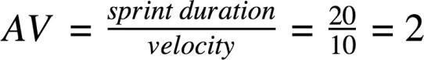

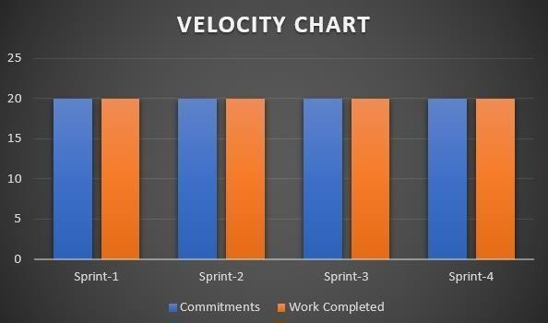



Burndown Chart:



A burn down chart is a graphical representation of work left to do versus time. It is often



used in agile [software development](https://www.visual-paradigm.com/scrum/what-is-agile-software-development/) methodologies suchas [Scrum](https://www.visual-paradigm.com/scrum/scrum-in-3-minutes/). However, burn down charts can be applied to any project containing measurable progress over time.

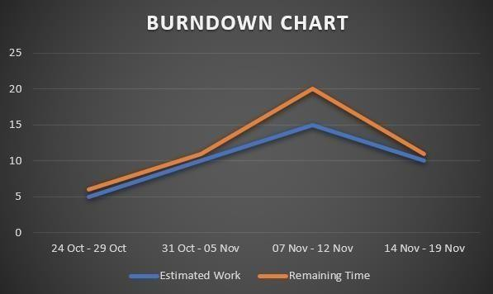

## Coding &Solutioning:

* 1. **Feature 1:**

{

margin: 0;

padding: 0;

}

body{

background:url(cr.jpg); background-position: center; background-size: cover;

}

div.main{

width: 400px;

margin: 100px auto 0px auto ;

}

h2{

text-align: center; padding: 20px;

font-family: Arial;

}

div.register{

background-color: rgba(0, 0, 0, 0.5);

width: 100%; font-size: 20px;

border-radius: 10px;

border: 1px solid rgba(255, 255, 255, 0.3); box-shadow: 2px 2px 15px

rgba(0,0,0,0.3);

color:#ff7200

}

form#register{ margin: 40px;

}

label{

font-family: Arial; font-size: 18px;

}

input#name{

width: 300px;

border: 1px solid #ff7200;

border-radius: 3px; outline: 0; padding: 7px;

background-color: #000;

box-shadow: inset 1px 1px 5px rgba(0, 0, 0, 0.3);

}

input#submit{

width: 240px; height: 40px; background: #ff7200; border: none;

margin-top: 30px; font-family: Arial; font-size: 18px; font-weight: bold; border-radius: 10px; cursor: pointer; color: #fff;

transition: 0.4s ease; margin-bottom: 20px;

}

label,h2{

text-shadow: 1px 1px 5px rgba(0, 0, 0, 0.3);

}

span{

color: #000;

text-shadow: 1px 1px 5px rgba(0, 0, 0, 0.3);

}

**import pandas as pd import numpy as np**

**import matplotlib.pyplot as plt**

**data=pd.read_excel("/content/Crude Oil Prices Daily.xlsx") data.isnull().any()**

**data.isnull().sum() data.dropna(axis=0,inplace=True) data.isnull().sum() data_oil=data.reset_index()['Closing Value'] data_oil**

**from sklearn.preprocessing import MinMaxScaler scaler=MinMaxScaler(feature_range=(0,1)) data_oil=scaler.fit_transform(np.array(data_oil).reshape(-1,1)) data_oil**

**plt.plot(data_oil) training_size=int(len(data_oil)*0.65) test_size=len(data_oil)-training_size**

**train_data,test_data=data_oil[0:training_size,:],data_oil[training_size:len(data_oil),:1] training_size,test_size**

**train_data.shape**

**def create_dataset(dataset,time_step=1): dataX,dataY=[],[]**

**for i in range(len(dataset)-time_step-1):**

**a=dataset[i:(i+time_step),0] dataX.append(a) dataY.append(dataset[i+time_step,0]) return np.array(dataX),np.array(dataY) time_step=10**

**x_train,y_train=create_dataset(train_data,time_step) x_test,y_test=create_dataset(test_data,time_step) print(x_train.shape),print(y_train.shape) print(x_test.shape),print(y_test.shape)**

**x_train x_train=x_train.reshape(x_train.shape[0],x_train.shape[1],1) x_test=x_test.reshape(x_test.shape[0],x_test.shape[1],1)**

**from tensorflow.keras.models import Sequential from tensorflow.keras.layers import Dense**

**from tensorflow.keras.layers import LSTM model=Sequential()**

**model.add(LSTM(50,return_sequences=True,input_shape=(10,1))) model.add(LSTM(50,return_sequences=True)) model.add(LSTM(50))**

**model.add(Dense(1)) model.summary()**

**model.compile(loss='mean_squared_error',optimizer='adam')**

**model.fit(x_train,y_train,validation_data=(x_test,y_test),epochs=3,batch_size=64,verbose= 1)**

**##Transformback to original form**

**train_predict=scaler.inverse_transform(train_data) test_predict=scaler.inverse_transform(test_data) ### Calculate RMSE performance metrics**

**import math**

**from sklearn.metrics import mean_squared_error math.sqrt(mean_squared_error(train_data,train_predict)) from tensorflow.keras.models import load_model model.save("crude_oil.hs")**

**### Plotting look_back=10**

**trainpredictPlot = np.empty_like(data_oil) trainpredictPlot[:, :]= np.nan**

**trainpredictPlot[look_back:len(train_predict)+look_back, :] = train_predict # shift test predictions for plotting**

**testPredictplot = np.empty_like(data_oil) testPredictplot[:,: ] = np.nan**

**testPredictplot[look_back:len(test_predict)+look_back, :] = test_predict # plot baseline and predictions plt.plot(scaler.inverse_transform(data_oil))**

**plt.show() len(test_data)**

**x_input=test_data[2866:].reshape(1,-1) x_input.shape temp_input=list(x_input)**

**temp_input=temp_input[0].tolist() temp_input**

**lst_output=[] n_steps=10 i=0 while(i<10):**

**if(len(temp_input)>10): #print(temp_input)**

**x_input=np.array(temp_input[1:]) print("{} day input {}".format(i,x_input)) x_input=x_input.reshape(1,-1)**

**x_input = x_input.reshape((1, n_steps, 1)) #print(x_input) yhat = model.predict(x_input, verbose=0)**

**print("{} day output {}".format(i,yhat)) temp_input.extend(yhat[0].tolist()) temp_input=temp_input[1:] #print(temp_input) lst_output.extend(yhat.tolist())**

**i=i+1 else:**

**x_input = x_input.reshape((1, n_steps,1)) yhat = model.predict(x_input, verbose=0) print(yhat[0]) temp_input.extend(yhat[0].tolist()) print(len(temp_input)) lst_output.extend(yhat.tolist())**

**i=i+1**

**day_new=np.arange(1,11) day_pred=np.arange(11,21) len(data_oil)**

**plt.plot(day_new, scaler.inverse_transform(data_oil[8206:])) plt.plot(day_pred, scaler.inverse_transform(lst_output)) df3=data_oil.tolist()**

**df3.extend(lst_output) plt.plot(df3[8100:]) df3=scaler.inverse_transform(df3).tolist()**

**{**

**"nbformat": 4,**

**"nbformat_minor": 0, "metadata": {**

**"colab": {**

**"provenance": []**

**},**

**"kernelspec": { "name": "python3",**

**"display_name": "Python 3"**

**},**

**"language_info": { "name": "python"**

**}**

**},**

**"cells": [**

**{**

**"cell_type": "code", "execution_count": null, "metadata": {**

**"id": "V2_KG9eVo0Dp"**

**},**

**"outputs": [], "source": [**

**"import numpy as np # linear algebra\n",**

**"import pandas as pd # data processing, CSV file I/O (e.g. pd.read_csv)\n", "import datetime\n",**

**"from pylab import rcParams\n", "import matplotlib.pyplot as plt\n", "import warnings\n",**

**"import itertools\n",**

**"import statsmodels.api as sm\n",**

**"from keras.models import Sequential\n", "from keras.layers import Dense\n", "from keras.layers import LSTM\n", "from keras.layers import Dropout\n",**

**"from sklearn.metrics import mean_squared_error\n",**

**"from keras.callbacks import ReduceLROnPlateau, EarlyStopping, ModelCheckpoint\n", "from sklearn.metrics import mean_squared_error\n",**

**"from sklearn.metrics import mean_absolute_error\n", "import seaborn as sns\n",**

**"sns.set_context(\"paper\", font_scale=1.3)\n", "sns.set_style('white')\n",**

**"import math\n",**

**"from sklearn.preprocessing import MinMaxScaler\n",**

**"# Input data files are available in the \"../input/\" directory.\n",**

**"# For example, running this (by clicking run or pressing Shift+Enter) will list all files under the input directory\n",**

**"warnings.filterwarnings(\"ignore\")\n", "plt.style.use('fivethirtyeight')\n", "import os\n",**

**"for dirname, _, filenames in os.walk('/kaggle/input'):\n", " for filename in filenames:\n",**

**" print(os.path.join(dirname, filename))\n"**

**]**

**},**

**{**

**"cell_type": "code",**

**"source": [**

**"dateparse = lambda x: pd.datetime.strptime(x, '%b %d, %Y')\n", "#Read csv file\n",**

**"from google.colab import files\n", "uploaded = files.upload()\n",**

**"df = pd.read_csv('BrentOilPrices.csv',parse_dates=['Date'], date_parser=dateparse)\n", "#Sort dataset by column Date\n",**

**"df = df.sort_values('Date')\n",**

**"df = df.groupby('Date')['Price'].sum().reset_index()\n", "df.set_index('Date', inplace=True)\n", "df=df.loc[datetime.date(year=2000,month=1,day=1):]"**

**],**

**"metadata": {**

**"colab": {**

**"base_uri": "https://localhost:8080/", "height": 74**

**},**

**"id": "YnLH29tkpmjs",**

**"outputId": "19171f42-d97c-4103-c66e-fb2ed0a9c3ee"**

**},**

**"execution_count": null, "outputs": [**

**{**

**"output_type": "display_data", "data": {**

**"text/plain": [**

**"<IPython.core.display.HTML object>"**

**],**

**"text/html": [**

**"\n",**

**" <input type=\"file\" id=\"files-a0e5cc1b-7073-4e18-a9a9-53cb7288cb0d\" name=\"files[]\" multiple disabled\n",**

**" style=\"border:none\" />\n",**

**" <output id=\"result-a0e5cc1b-7073-4e18-a9a9-53cb7288cb0d\">\n",**

**" Upload widget is only available when the cell has been executed in the\n", " current browser session. Please rerun this cell to enable.\n",**

**" </output>\n",**

**" <script>// Copyright 2017 Google LLC\n", "//\n",**

**"// Licensed under the Apache License, Version 2.0 (the \"License\");\n", "// you may not use this file except in compliance with the License.\n", "// You may obtain a copy of the License at\n",**

**"//\n",**

**"//** [**http://www.apache.org/licenses/LICENSE-2.0\n",**](http://www.apache.org/licenses/LICENSE-2.0\n) **"//\n",**

**"// Unless required by applicable law or agreed to in writing, software\n", "// distributed under the License is distributed on an \"AS IS\" BASIS,\n",**

**"// WITHOUT WARRANTIES OR CONDITIONS OF ANY KIND, either express or**

**implied.\n",**

**"// See the License for the specific language governing permissions and\n", "// limitations under the License.\n",**

**"\n",**

## Features 2:

import numpy as np # linear algebra

import pandas as pd # data processing, CSV file I/O (e.g. pd.read_csv) import datetime

from pylab import rcParams import matplotlib.pyplot as plt import warnings

import itertools

import statsmodels.api as sm

from keras.models import Sequential from keras.layers import Dense

from keras.layers import LSTM from keras.layers import Dropout

from sklearn.metrics import mean_squared_error

from keras.callbacks import ReduceLROnPlateau, EarlyStopping, ModelCheckpoint from sklearn.metrics import mean_squared_error

from sklearn.metrics import mean_absolute_error import seaborn as sns

sns.set_context("paper", font_scale=1.3) sns.set_style('white')

import math

from sklearn.preprocessing import MinMaxScaler

# Input data files are available in the "../input/" directory.

# For example, running this (by clicking run or pressing Shift+Enter) will list all files under the input directory

warnings.filterwarnings("ignore") plt.style.use('fivethirtyeight') import os

for dirname, _, filenames in os.walk('/kaggle/input'): for filename in filenames:

print(os.path.join(dirname, filename))

regressor = Sequential()

regressor.add(LSTM(units = 60, return_sequences = True, input_shape = (X_train.shape[1], 1))) regressor.add(Dropout(0.1))

regressor.add(LSTM(units = 60, return_sequences = True)) regressor.add(Dropout(0.1))

regressor.add(LSTM(units = 60)) regressor.add(Dropout(0.1))

regressor.add(Dense(units = 1))

regressor.compile(optimizer = 'adam', loss = 'mean_squared_error') reduce_lr = ReduceLROnPlateau(monitor='val_loss',patience=5)

history =regressor.fit(X_train, Y_train, epochs = 20, batch_size = 15,validation_data=(X_test, Y_test), callbacks=[reduce_lr],shuffle=False)

**MODEL TRAINING**

train_predict = regressor.predict(X_train) test_predict = regressor.predict(X_test) train_predict = sc.inverse_transform(train_predict) Y_train = sc.inverse_transform([Y_train]) test_predict = sc.inverse_transform(test_predict) Y_test = sc.inverse_transform([Y_test])

**PREDICTION**

print('Train Mean Absolute Error:', mean_absolute_error(Y_train[0], train_predict[:,0]))

print('Train Root Mean Squared Error:',np.sqrt(mean_squared_error(Y_train[0], train_predict[:,0])))

print('Test Mean Absolute Error:', mean_absolute_error(Y_test[0], test_predict[:,0]))

print('Test Root Mean Squared Error:',np.sqrt(mean_squared_error(Y_test[0], test_predict[:,0]))) plt.figure(figsize=(8,4))

plt.plot(history.history['loss'], label='Train Loss') plt.plot(history.history['val_loss'], label='Test Loss') plt.title('model loss')

plt.ylabel('loss') plt.xlabel('epochs') plt.legend(loc='upper right') plt.show();

aa=[x for x in range(180)] plt.figure(figsize=(8,4))

plt.plot(aa, Y_test[0][:180], marker='.', label="actual") plt.plot(aa, test_predict[:,0][:180], 'r', label="prediction") plt.tight_layout()

sns.despine(top=True) plt.subplots_adjust(left=0.07) plt.ylabel('Price', size=15) plt.xlabel('Time step', size=15) plt.legend(fontsize=15)

1. Testing:
   1. Test Case::

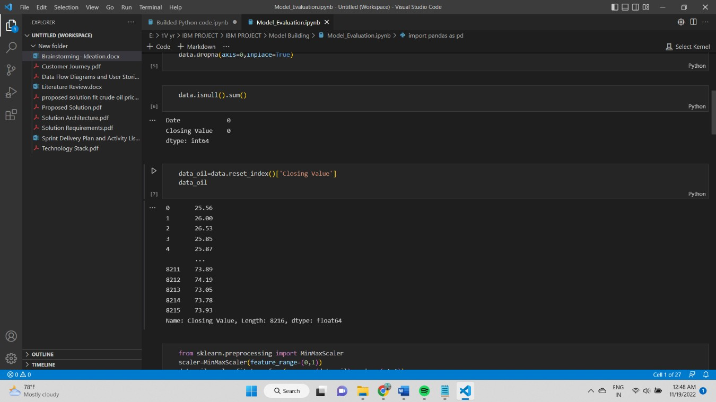

* 1. User acceptance Testing:



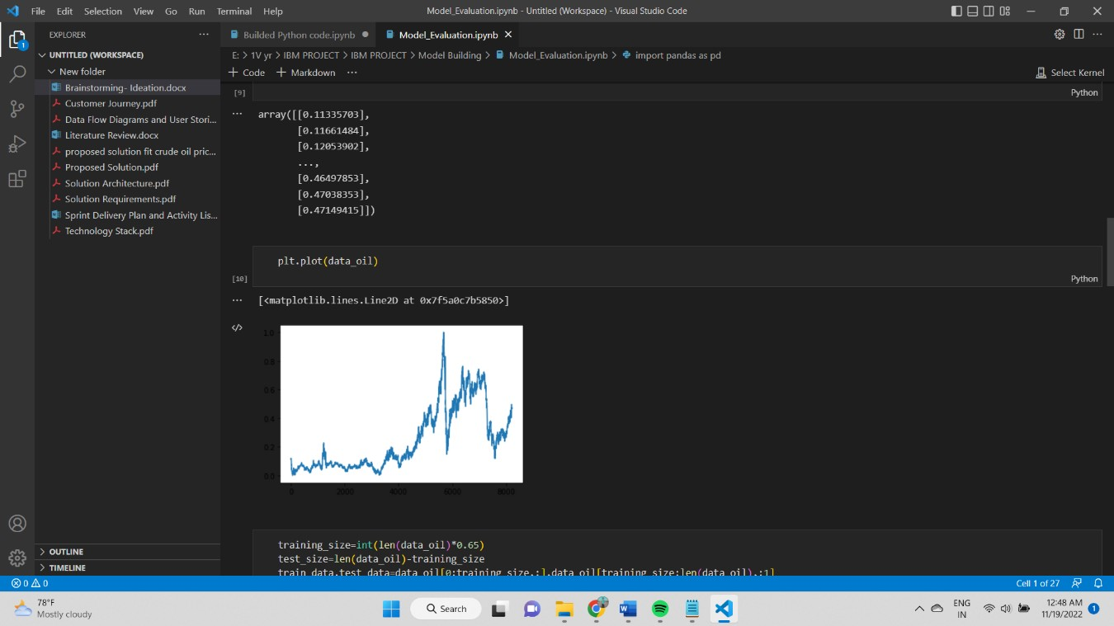

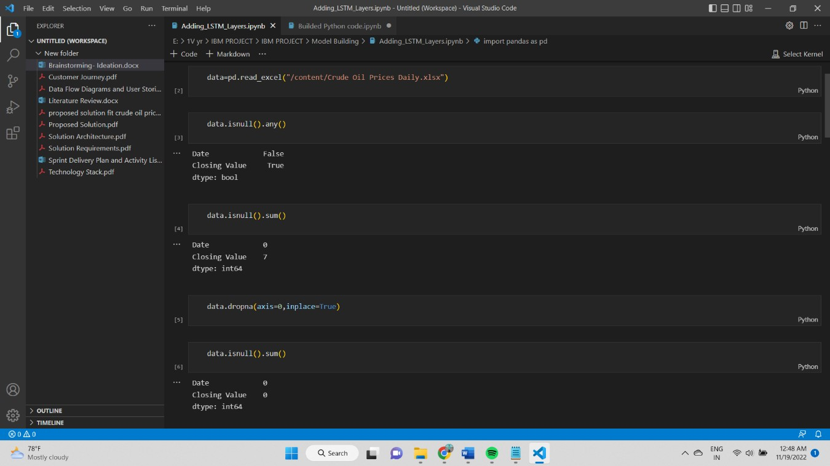

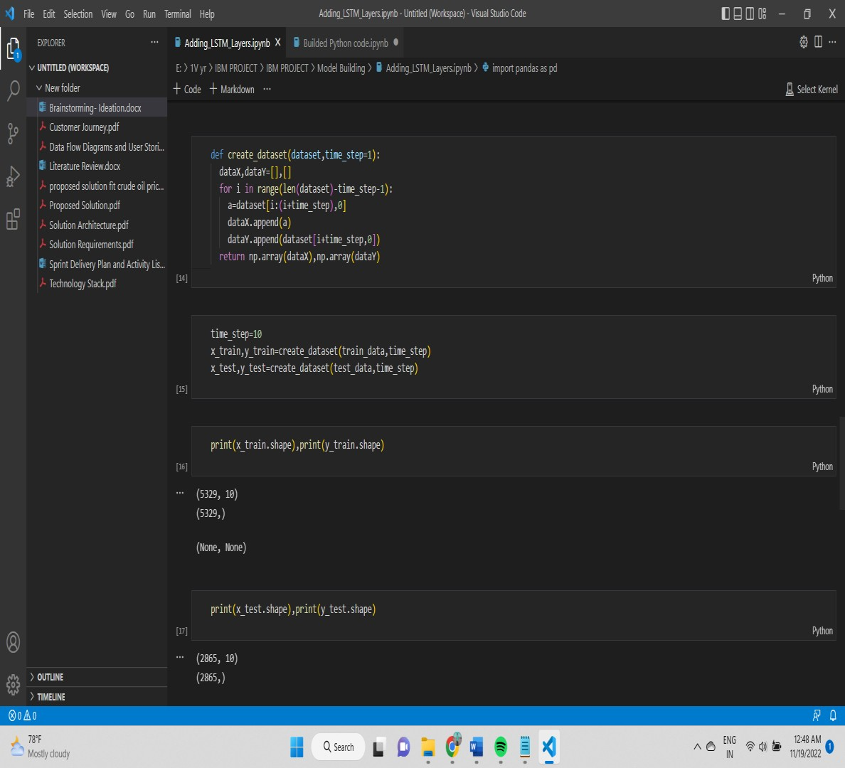

1. **Results:**
   1. **Performance Metrics:**

performance metrics, the mean absolute error (MAE) and the root mean square error (RMSE) which have been frequently used in previous studies (e.g., Tang et al. 2015; Lerner and Seru 2021), formulated as:

MAE=1T2−1∑t=T1+2T1+T2|yt−y^t|RMSE=1T2−1∑t=T1+2T1+T2(yt−y^t)2−−−−−−−−−−

−−−−−−−−

Performance evaluation metrics

In order to evaluate the one-step prediction performance of the models from comprehensive respects, we select two conventional



### ⎷

where T1 and T2 are the length of the training and testing set respectively, and yt and yˆt are the actual and predicted returns on real oil price. Obviously, smaller MAE and RMSE indicate a better prediction model.

In addition, we use another popular evaluation metric, the out-of-sample R-squared, i.e., R2OOS, which compares different forecast approaches with a benchmark model. In this paper, we use the random walk model as benchmark, which is solidly based on the Efficiency Market Hypothesis (EMH), and consequently, the R2OOS statistic is defined as:

R2OOS=100×[1−∑T1+T2t=T1+2(yt−y^t)2∑T1+T2t=T1+2(yt−y^RWt)2]

where the yˆRWt is the random walk predictions. The R2OOS measures the performance of candidate prediction approach relative to the trivial prediction, hence a higher and positive R2OOS indicates a better accuracy of forecasting, compared with the benchmark as R2OOS=0. For the evaluation of return prediction, the information coefficient (IC) has been widely adoptedin prior studies, see for example Guerard et al. (2021). The IC describes the correlation betweenthe predicted and realized asset returns as:

1. **Advantage & Disadvantage:**

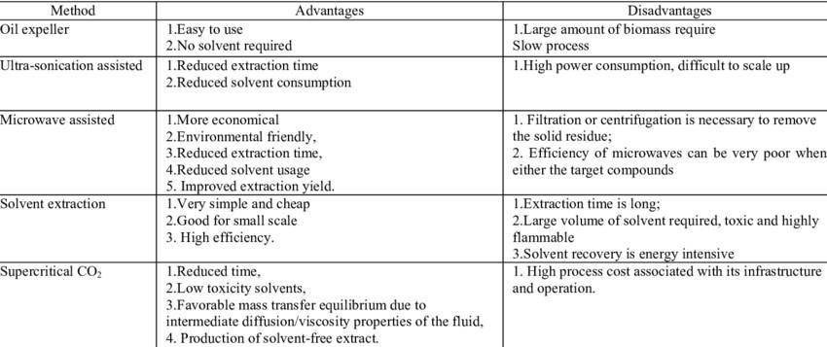

**11&12. Conclusion and Future Scope:**

1. Forecasting crude oil prices is a very challenging problem due to the high volatility of oil prices.
2. In this paper, we developed a new oil price prediction approach using ideas and tools from stream learning, a machine learning paradigm for analysis and inference of continuous flow of non-stationary data.
3. Our stream learning model will be updated whenever new oil price data are available, so the model continuously evolves over time, and can capture the changing pattern of oil prices.

## 13. Appendix:

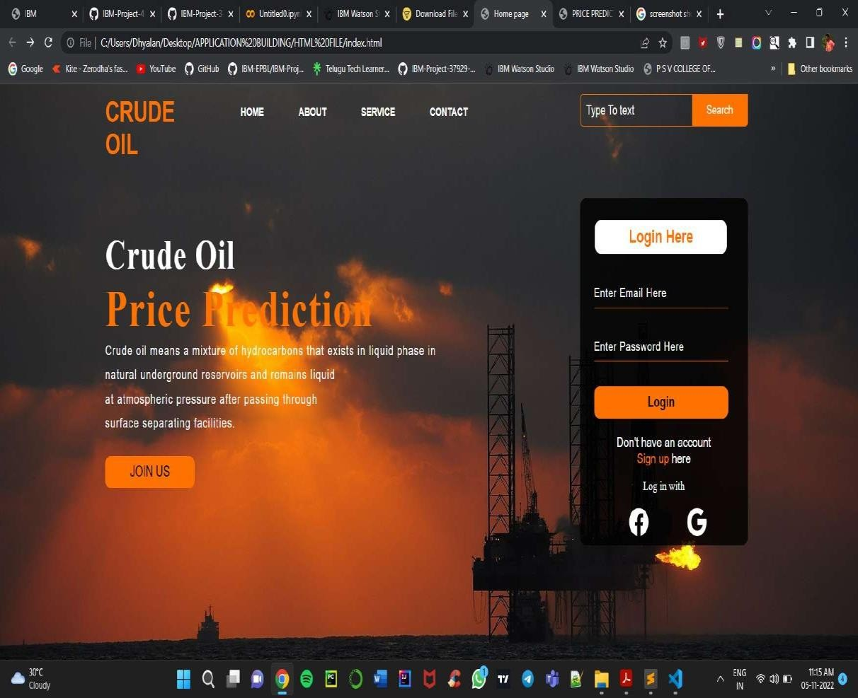

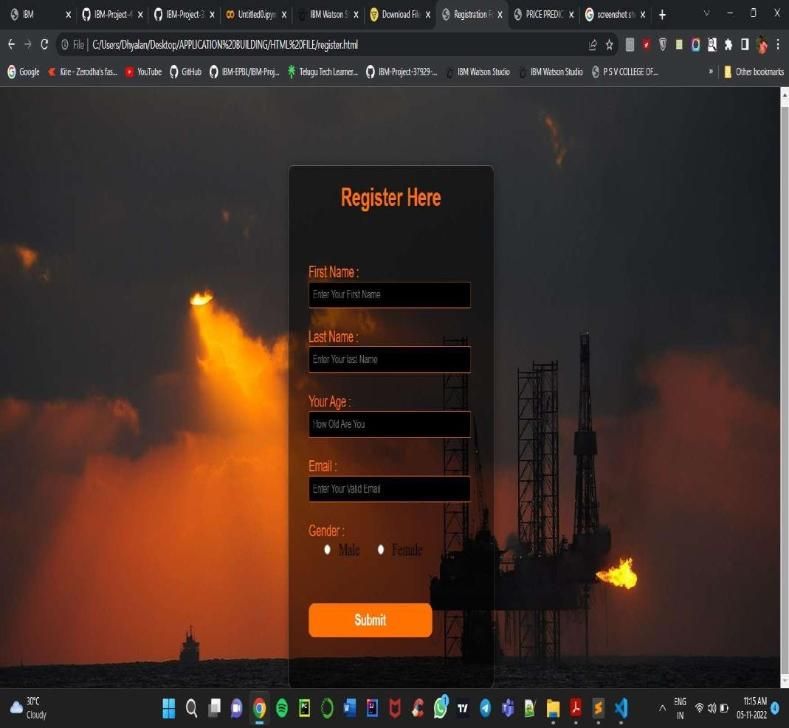

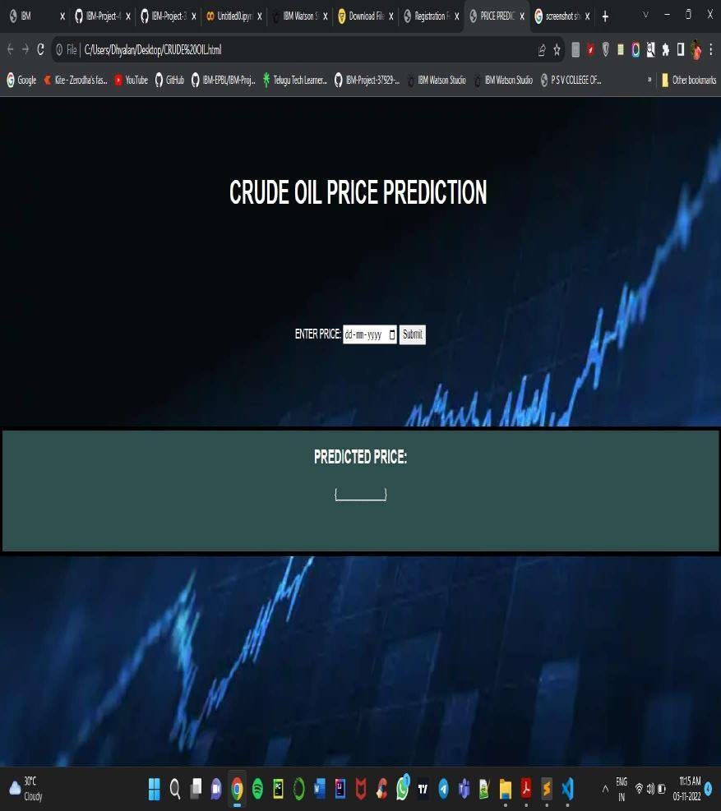

Source code:

*{

margin: 0;

padding: 0;

}

.main{

width: 100%; background:url(cr.jpg); background-position: center; background-size: cover; height: 100vh;

}

.navbar{

width: 1200px; height: 75px; margin: auto;

}

.icon{

width: 200px; float: left; height: 70px;

}

.logo{

color: #ff7200; font-size: 35px; font-family: Arial; padding-left: 20px; float: left; padding-top: 10px; margin-top: 5px

}

.menu{

width: 400px; float: left; height: 70px;

}

ul{

}

float: left; display: flex;

justify-content: center; align-items: center;

ul li{

list-style: none; margin-left: 62px; margin-top: 27px; font-size: 14px;

}

ul li a{

text-decoration: none; color: #fff;

font-family: Arial; font-weight: bold;

transition: 0.4s ease-in-out;

}

ul li a:hover{ color: #ff7200;

}

.search{

width: 330px; float: left;

margin-left: 270px;

}

.srch{

font-family: 'Times New Roman'; width: 200px;

height: 40px; background: transparent;

border: 1px solid #ff7200; margin-top: 13px;

color: #fff;

border-right: none; font-size: 16px; float: left; padding: 10px;

border-bottom-left-radius: 5px; border-top-left-radius: 5px;

}

.btn{

width: 100px; height: 40px; background: #ff7200;

border: 2px solid #ff7200; margin-top: 13px;

color: #fff; font-size: 15px;

border-bottom-right-radius: 5px; border-bottom-right-radius: 5px; transition: 0.2s ease;

cursor: pointer;

}

.btn:hover{

color: #000;

}

.btn:focus{

outline: none;

}

.srch:focus{

outline: none;

}

.content{

width: 1200px; height: auto; margin: auto; color: #fff; position: relative;

}

.content .par{

padding-left: 20px; padding-bottom: 25px; font-family: Arial; letter-spacing: 1.2px; line-height: 30px;

}

.content h1{

font-family: 'Times New Roman'; font-size: 50px;

padding-left: 20px; margin-top: 9%; letter-spacing: 2px;

}

.content .cn{

width: 160px; height: 40px; background: #ff7200; border: none;

margin-bottom: 10px; margin-left: 20px; font-size: 18px; border-radius: 10px; cursor: pointer; transition: .4s ease;

}

.content .cn a{

text-decoration: none; color: #000; transition: .3s ease;

}

.cn:hover{

background-color: #fff;

}

.content span{ color: #ff7200; font-size: 65px

}

.form{

width: 250px; height: 380px;

background: linear-gradient(to top, rgba(0,0,0,0.8)50%,rgba(0,0,0,0.8)50%);

position: absolute; top: -20px;

left: 870px;

transform: translate(0%,-5%); border-radius: 10px; padding: 25px;

}

.form h2{

width: 220px;

font-family: sans-serif; text-align: center; color: #ff7200;

font-size: 22px; background-color: #fff; border-radius: 10px; margin: 2px;

padding: 8px;

}

.form input{

width: 240px; height: 35px;

background: transparent;

border-bottom: 1px solid #ff7200; border-top: none;

border-right: none; border-left: none; color: #fff;

font-size: 15px; letter-spacing: 1px; margin-top: 30px;

font-family: sans-serif;

}

.form input:focus{ outline: none;

}

::placeholder{

color: #fff;

font-family: Arial;

}

.btnn{

width: 240px; height: 40px; background: #ff7200; border: none;

margin-top: 30px; font-size: 18px; border-radius: 10px; cursor: pointer; color: #fff;

transition: 0.4s ease;

}

.btnn:hover{

background: #fff; color: #ff7200;

}

.btnn a{

text-decoration: none; color: #000;

font-weight: bold;

}

.form .link{

font-family: Arial, Helvetica, sans-serif; font-size: 17px;

padding-top: 20px; text-align: center;

}

.form .link a{

text-decoration: none; color: #ff7200;

}

.liw{

padding-top: 15px; padding-bottom: 10px; text-align: center;

}

.icons a{

text-decoration: none; color: #fff;

}

.icons ion-icon{ color: #fff; font-size: 40px;

padding-left: 60px; padding-top: 5px;

transition: 0.3s ease;

}

.icons ion-icon:hover{ color: #ff7200;

}

@media screen and (max-width:1200px) {

/*Normal Screen*/

.navbar{

width: 100%; height: 100px;

}

ul{

}

margin-left: 30px;

ul li{

margin-left: 60px;

}

ul li a{

font-size: 1.6vw;

}

.search{

margin-top: 3px; margin-left: 290px;

}

.srch{

height: 40px; width: 190px; font-size: 14px;

}

.btn{

height:40px; width: 80px;

}

.content{

width: 100%;

}

.content h1, .content span{ font-size: 4.5vw;

}

.content .par{ width: 90%;

font-size: 1.5vw;

}

.content .cn{

width: 13%; height: 3.5vw; font-size: 1.8vw;

}

.content a{

font-size: 1.6vw

}

}

@media screen and (max-width:1170px) {

/*Login-box*/

.main{

padding-left: 20px; height: 180vh;

}

.form{

margin-left: -30px; width: 250px; height: 370px;

background: linear-gradient(to top, rgba(0,0,0,0.8)50%,rgba(0,0,0,0.8)50%);

position: absolute; top: 420px;

left: 50px;

transform: translate(0%,-5%); border-radius: 10px; padding: 25px;

}

.form input{

width: 240px; height: 35px;

background: transparent;

border-bottom: 1px solid #ff7200; border-top: none;

**Githup & Project Demo Link:**

**https://github.com/IBM- EPBL/IBM-Project-46443-1660747271**



THANK YOU !!!